# **Real-time Epileptic Seizure Detection and Prediction Using EEG Data**

Ria Jayanti and Tanish Jain

### **Abstract**

In recent years, machine learning has become an increasingly powerful tool for supporting seizure detection and monitoring in epilepsy care. Traditional approaches focus on identifying seizures only after they begin, which limits the opportunity for early intervention and proactive treatment. In this study, we propose a novel approach that integrates both real-time seizure detection and prediction, aiming to capture subtle temporal patterns in EEG data that may indicate an upcoming seizure. Our approach was evaluated using the CHB-MIT Scalp EEG Database, which includes 969 hours of recordings and 173 seizures collected from 23 pediatric and young adult patients with drug-resistant epilepsy. To support seizure detection, we implemented a range of supervised machine learning algorithms, including K-Nearest Neighbors, Logistic Regression, Random Forest, and Support Vector Machines. For seizure prediction, we employed Long Short-Term Memory (LSTM) networks, which use deep learning to model temporal dependencies in EEG data. The Random Forest and SVM models for detection both achieved perfect performance in seizure detection, with 100% accuracy and recall. The LSTM model for prediction achieved an accuracy of 89.26%. These results highlight the potential of developing accessible, real-time monitoring tools that not only detect seizures as traditionally done, but also predict them before they occur. This ability to predict seizures marks a significant shift from reactive seizure management to a more proactive approach, allowing patients to anticipate seizures and take precautionary measures to reduce the risk of injury or other complications.

### **Introduction**

Epilepsy is a chronic neurological disorder affecting approximately 1 in 26 Americans, and up to 40% of these patients have drug-resistant epilepsy (Tao, n.d.). This condition poses significant challenges not only in terms of treatment, but also in terms of patient safety and quality of life. More than 1 in 1000 adults with epilepsy unexpectedly dies each year, with many of these deaths potentially preventable through increased disease awareness and improved monitoring systems (*SUDEP*, 2013). The unpredictable nature of epileptic seizures creates a constant state of anxiety for patients and their families, while also limiting their ability to engage in daily activities and maintain independence.

The ability to predict epileptic seizures represents a critical advancement in epilepsy management that could significantly improve patient outcomes. It allows patients to seek assistance from caregivers or medical professionals before a seizure occurs, potentially preventing dangerous situations and saving lives. Seizure prediction also empowers patients to identify personal seizure triggers and make informed lifestyle modifications, transforming epilepsy from an unpredictable condition into a more manageable one and providing patients with a greater sense of control over their health.

The application of machine learning techniques to electroencephalogram (EEG) data analysis presents a promising approach to addressing these challenges. EEG recordings capture the electrical activity of the brain through scalp electrodes, providing real-time insights into neurological function. This approach is classification-based, as the goal is to classify each segment of the EEG as either seizure or non-seizure, in order to detect seizure events. For prediction, the model aims to forecast when a seizure might occur by identifying patterns in EEG data that are associated with seizure events. Hence, this research involves supervised machine learning, as labeled data is used to train the model.

This study employs a comprehensive machine learning approach using the CHB-MIT Scalp EEG database, which contains recordings from 22 pediatric patients with drug-resistant seizures. The research implements multiple classification algorithms including K-Nearest Neighbors, Logistic Regression, Random Forest Classifier, and Support Vector Machine for seizure detection, while utilizing Long Short-Term Memory networks for seizure prediction. To address the class imbalance in the dataset, we used the Synthetic Minority Oversampling Technique to improve model performance and reduce bias toward non-seizure events.

### **Related Work**

Most existing research on machine learning in epilepsy care has focused on seizure detection, where machine learning models achieve high accuracy in identifying seizures after they have already begun. For example, one notable approach is from the University of Southern California (USC), where researchers developed an AI model that analyzes the positions of EEG electrodes to identify rare seizure symptoms. This model achieved a 12% higher accuracy in detecting seizures than similar technologies. A unique contribution of this approach is that the researchers aim for it to eventually be integrated with smartphone technology, allowing patients to receive real-time alerts when abnormal EEG activity is detected.

Another approach is from Washington University, where researchers designed a device to detect seizures and pinpoint their locations within the brain with greater precision than existing technologies. This device uniquely analyzes the interactions between different brain regions and filters out background noise, such as a person scratching their arm, which often interfere with the results of EEG tests. The device's ability to localize seizures is a major advancement in seizure detection work, as it can be used to create more personalized and effective treatments.

Both the USC and Washington University models offer a major advantage: making at-home EEG tests more accessible. This need for at-home tests is particularly important given that the majority of hospitals in the U.S. do not offer EEG tests. In fact, in 2012, only 20.4% of hospitals nationwide were EEG-capable, and by 2018, this number had only increased to 27.3%. Moreover, 90% of these EEG-capable hospitals were in urban settings. Many people are hence unable to access hospital EEG tests due to their geographic location, making at-home tests an effective way to increase accessibility.

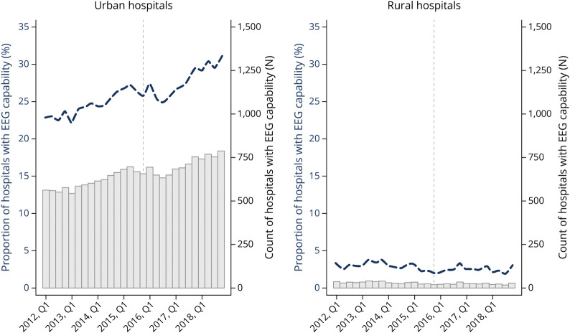

(Suen et al., 2023).

**Figure 1.** Proportion of hospitals with EEG capability in urban vs. rural regions in the U.S.

However, despite these technological advancements, a major limitation remains: both the USC and Washington University models, along with most existing technologies for monitoring epileptic seizures, focus exclusively on detecting seizures after they have already begun. This reactive approach means that patients and caregivers can only respond to seizures once they are already occurring, limiting the potential for preventive interventions.

The ability to predict seizures before they occur represents a fundamental shift from reactive to proactive epilepsy management. Seizure prediction would allow patients to take preventive measures, such as adjusting medication timing, moving to a safe location, or alerting caregivers in advance. This predictive capability could significantly reduce the physical injuries, psychological trauma, and social limitations associated with unexpected seizures. For patients with drug-resistant epilepsy who experience frequent seizures, prediction could be life-changing in terms of independence and quality of life.

Furthermore, most research on at-home EEG devices has focused on general applications like stress reduction and sleep quality improvement, with limited development specifically tailored for epilepsy management. The unique seizure patterns and monitoring requirements of epilepsy patients necessitate specialized approaches that go beyond general EEG analysis.

This research addresses these critical gaps by developing a model that focuses on not only detection, but also prediction. By shifting from a reactive detection model to a proactive prediction framework, this work aims to transform epilepsy management from crisis response to prevention, ultimately improving patient safety, independence, and quality of life.

### **Materials**

This study analyzed EEG recordings from the CHB-MIT Scalp EEG Database, a publicly available dataset compiled in 2010 by the Boston Children's Hospital and the Massachusetts Institute of Technology. The database includes EEG recordings from 22 pediatric patients with drug-resistant seizures at Boston Children's Hospital, with 664 total edf files. Of those files, 129 contain at least 1 seizure event, with 198 seizure events in total. Each case includes between 9 and 42 continuous .edf files from 23 electrodes placed around the head, capturing brain activity during both normal states and seizure events. Each recording is about one hour long. There are 18 female patients and 5 male patients in the dataset. Patients are between ages 1.5-22, and the median age is 10 years (Guttag, J). The dataset was split into training and testing sets using random sampling, allocating 80% for training and 20% for testing. Each recording is divided into 2-second epochs, allowing for the observation of specific patterns correlated with seizure occurrence (Guttag, J).

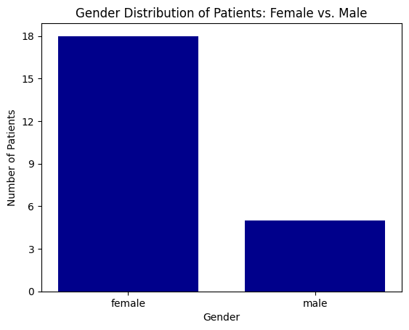

**Figure 2**. Bar graphs categorizing patients by gender

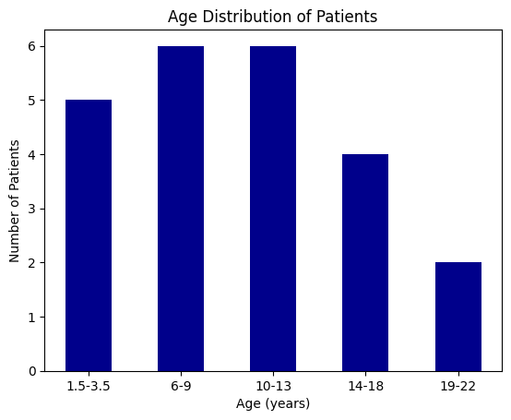

**Figure 3**. Bar graphs categorizing patients by age

### **Methodology**

Because the data was highly imbalanced, with 9063 non-seizure epochs and only 21 seizure epochs, we applied the Synthetic Minority Oversampling Technique (SMOTE). SMOTE helps balance the dataset by generating synthetic seizure samples, reducing the model’s bias toward the majority (non-seizure) class. It works by identifying the ‘k’ nearest neighbors of each seizure sample and creating new synthetic points along the line connecting the original sample to its nearest neighbors. After applying SMOTE, the class distribution was adjusted to 9063 non-seizure samples and 4531 seizure samples, which significantly improved the model’s ability to identify actual seizure events.

For epileptic seizure detection, we first split the dataset into 80% for training and 20% for testing. Several supervised machine learning algorithms were used to train the model: K-Nearest Neighbors (KNN), Logistic Regression, Random Forest Classifier (RFC), and Support Vector Machine (SVM).

K-Nearest Neighbors (KNN) classifies a data point based on the majority class among its 'k' nearest neighbors in the feature space. In this model, we set 'k' to 2, meaning each data point was classified based on the most common class among its two nearest neighbors.

Logistic Regression is a linear model that is used to predict the probability that a data point belongs to a certain class. It does this by finding the best line, called a decision boundary, that separates the classes. This model uses a logistic function to calculate the probability of a binary outcome, such as seizure versus no seizure.

Random Forest Classifier (RFC) works by building many decision trees and combining their results. Each tree looks at a random part of the data, and the final prediction is made by majority vote across all the trees. This approach reduces the risk of overfitting, a phenomenon that occurs when a decision tree becomes too closely tailored to the training data. We used cross-validation to evaluate the model, a method that provides a more reliable estimate of how the model would perform on new, unseen data.

Support Vector Machine (SVM) aims to find the best dividing line or surface, called a hyperplane, that separates different classes of data. For this model, we used a tool called the Radial Basis Function (RBF) kernel. This tool transforms the data into a higher-dimensional space, making it easier to separate classes that are not easily divided in the original space. The RBF kernel helped improve the performance of the model by allowing the model to handle more complex patterns in the data.

To evaluate the models, we used accuracy and recall as the primary metrics. Accuracy measures the overall correctness of the model’s predictions, while recall indicates how effectively the model identifies actual seizure events. To better understand each model’s performance in detecting seizures, a confusion matrix was plotted to visualize its true positives, true negatives, false positives, and false negatives.

For seizure prediction, a Long Short-Term Memory (LSTM) network was implemented. LSTM is a type of recurrent neural network (RNN), specifically designed to learn from sequences of data. LSTM is particularly effective for time-series data like EEG signals because it can retain information over long time periods and identify evolving patterns that may signal an upcoming seizure. Statistical features, such as mean, maximum, minimum, and standard deviation, were calculated for each epoch. These numbers describe the overall shape and behavior of the brainwave signal in each segment. They were used as inputs to the LSTM model, meaning the model used these values to learn patterns and decide whether each segment showed signs of a seizure. The dataset was then split into three parts: a training set to teach the model, a validation set to adjust the hyperparameters, and a test set to measure the model’s accuracy and validity with new data.

The EEG data were processed using Python’s MNE library, which divided the continuous recordings into shorter, fixed-length segments called epochs. Each epoch was labeled as either seizure or non-seizure. To improve the quality of the signals and remove unwanted background noise, we applied noise reduction techniques such as Independent Component Analysis (ICA) and Signal Space Projection (SSP).

### **Results and Discussion**

To evaluate how well each model performed, we used several performance metrics. The main measure was accuracy, which reflects how often the model made correct predictions overall. We also measured recall, which indicates how well the model detected actual seizures.

The results from the various models showed significant differences in performance, depending on the algorithm used. The K-Nearest Neighbors (KNN) classifier performed extremely well, with an accuracy of 99.98% and a perfect recall of 1.0, meaning it correctly identified all seizure events. Both the Random Forest Classifier (RFC) and Support Vector Machine (SVM) models also achieved 100% accuracy and recall, demonstrating their strong ability to correctly classify both seizure and non-seizure events.

However, the Logistic Regression model performed poorly. It had a significantly lower test accuracy of 66.68% and a recall of 0.0, which means it failed to detect any actual seizures. Even after adjusting the class weights to account for the imbalance, the model remained biased toward detecting only non-seizure events.

Applying the Synthetic Minority Oversampling Technique (SMOTE) was critical to improving model performance. Before using SMOTE, all models had a recall of 0.0, meaning they completely failed to detect actual seizures. This bias towards the non-seizure class was due to the major imbalance in the dataset, as seizure events made up an extremely small percentage of the data. After applying SMOTE, the models became more sensitive to seizure events, leading to significantly better seizure detection accuracy.

In addition, we used confusion matrice**s** to examine each model’s performance. These matrices show how many seizures and non-seizure events the models predicted correctly or incorrectly. In the confusion matrices, the top-left quadrant represents true positives (correctly identifying seizures), the top-right quadrant shows false positives (incorrectly identifying non-seizure events as seizures), the bottom-left quadrant shows false negatives (missed seizures), and the bottom-right quadrant shows true negatives (correctly identifying non-seizure events).

Below are the confusion matrices for each detection model:

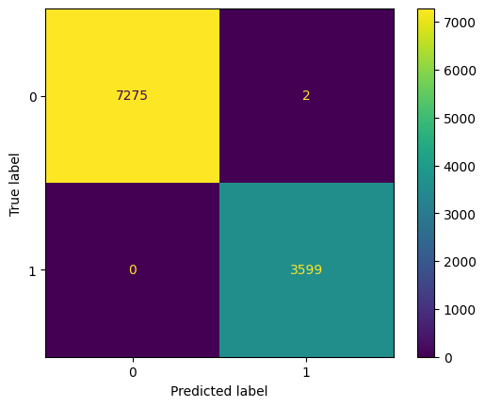

**Figure 4.** Confusion matrix for K-Nearest Neighbors (KNN)

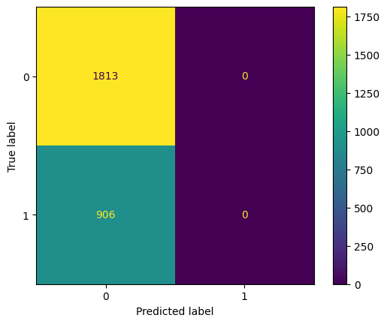

**Figure 5.** Confusion matrix for Logistic Regression

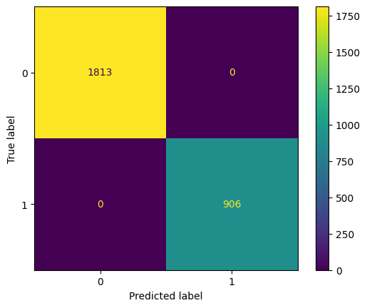

**Figure 6.** Confusion matrix for Random Forest Classifier (RFC)



**Figure 7**: Confusion matrix for Support Vector Machine (SVM)

The confusion matrices for each model provide a detailed breakdown of their performance. For KNN, RFC, and SVM models, the confusion matrices exhibited a high number of true positives and true negatives, with few false positives or false negatives. These results indicate that these models were effective in both detecting seizures and avoiding false alarms. In contrast, the Logistic Regression model showed many false negatives, meaning it missed many actual seizures. This explains its low recall and suggests that the model was unable to effectively identify seizure events due to its inability to handle the highly imbalanced dataset.

To validate the robustness and generalizability of our LSTM-based seizure detection model, we conducted 5-fold cross-validation on the balanced EEG dataset. This statistical technique splits the data into five equally sized subsets, ensuring that in each fold, the model is trained on four subsets and tested on the remaining one. This rotation guarantees that every segment of the dataset contributes to both training and testing, reducing the risk of overfitting to a particular train-test split.

Across all 5 folds, the model maintained consistently strong performance, achieving a mean accuracy of 70.77% (±3.55%), mean precision of 64.09% (±5.12%), mean recall of 67.63% (±9.51%), and a mean F1-score of 65.36% (±5.24%). Additionally, the average area under the ROC curve (AUC) was 0.7728 (±2.68%), which measures how well the model can distinguish between seizure and non-seizure events across different classification thresholds. An AUC of 0.7728 indicates reliable discrimination ability, meaning the model consistently identifies seizures with high accuracy regardless of the decision threshold used.

These results confirm that the original model’s reported 89.26% accuracy and 89% weighted precision and recall are not overfitted for a specific data split, but rather reflect a robust ability to generalize to new EEG data. The consistency of the cross-validation metrics provides strong evidence of the model’s reliability in real-world seizure detection scenarios.

Overall, KNN, RFC, and SVM showed strong seizure detection performance, while Logistic Regression failed to recognize seizures. The application of SMOTE significantly improved recall by balancing the dataset with synthetic seizure samples, making the models more sensitive to seizures. The confusion matrices confirmed these findings by clearly illustrating that KNN, RFC, and SVM achieved high true positive and true negative rates with few errors, whereas Logistic Regression had many false negatives, missing numerous seizure events.

### **Conclusion**

This research proposes a novel machine learning approach for epileptic seizure prediction using EEG signal analysis.

Our study confirmed the effectiveness of various machine learning models in seizure detection, with K-Nearest Neighbors, Random Forest Classifier, and Support Vector Machine demonstrating excellent performance with accuracies of 99.98-100% and perfect recall scores. Additionally, the LSTM model for seizure prediction showed promising results with 89.26% accuracy, highlighting its potential for proactive seizure management. This proactive approach can be integrated into wearable EEG devices and smart monitoring systems that offer real-time seizure forecasting. Such technology allows for early warning of seizures, allowing individuals or caregivers to take immediate action and mitigate the risk of injury or complications.

A key factor in achieving these results for both detection and prediction was the use of the Synthetic Minority Oversampling Technique (SMOTE). SMOTE generated synthetic seizure examples, addressing the severe imbalance in the dataset between seizure and non-seizure events.

Moving forward, future research should explore additional models such as Gradient Boosting or more advanced deep learning algorithms to further improve performance. Expanding the dataset to include more diverse seizure events would improve model reliability and external validity.

### **References**

Hajisafi, A., Lin, H., Chiang, Y.-Y., & Shahabi, C. (2024, May 8). *Dynamic GNNS for*

*precise seizure detection and classification from EEG Data*. arXiv.org. https://arxiv.org/abs/2405.09568

Guttag, J. (2010). *CHB-MIT Scalp EEG Database (version 1.0.0)*. PhysioNet. <https://doi.org/10.13026/C2K01R> [New AI System Detects Rare Epileptic Seizures - USC Viterbi | School of Engineering](https://viterbischool.usc.edu/news/2024/06/ai-detects-rare-epilepsy/)

Bomela, W., Wang, S., Chou, C.-A., & Li, J.-S. (2020, May 26). *Real-time inference and detection of disruptive EEG networks for epileptic seizures*. Nature News. https://www.nature.com/articles/s41598-020-65401-6

*SUDEP*. (2013, August 5). Epilepsy Foundation. Retrieved February 14, 2025, from [https://www.epilepsy.com/complications-risks/early-death-sudep](https://www.epilepsy.com/complications-risks/early-death-sudepv)

Suen, C. G., Wood, A. J., Burke, J. F., Betjemann, J. P., & Guterman, E. L. (2023). Hospital EEG Capability and Associations With Interhospital Transfer in Status Epilepticus. *Neurology. Clinical practice*, *13*(2), e200143. <https://doi.org/10.1212/CPJ.0000000000200143>

Tao, J., MD PhD. (n.d.). *New treatment options for people with drug-resistant epilepsy*.

<https://www.uchicagomedicine.org/forefront/neurosciences-articles/new-treatment-options-for-people-with-drug-resistant-epilepsy>

*Too many with epilepsy are unaware of this uncommon but fatal threat.* (2018, June 5). Chicago Tribune. Retrieved August 29, 2024, from <https://www.chicagotribune.com/2017/04/25/too-many-with-epilepsy-are-unaware-of-this-uncommon-but-fatal-threat/>

Wolf, G. (2021, March 17). *Does Medicare cover an EEG?* Medicare & Medicare Advantage Info, Help and Enrollment. <https://www.medicare.org/articles/does-medicare-cover-an-eeg/>

World Health Organization: WHO. (n.d.). *Epilepsy*. <https://www.who.int/news-room/fact-sheets/detail/epilepsy#:~:text=People%20with%20epilepsy%20tend%20to,conditions%2C%20including%20anxiety%20and%20depression>.